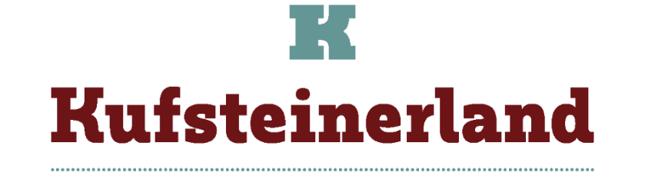

**CHRISTMAS TIME IN KUFSTEINERLAND IS NOT JUST ABOUR CHRISTMAS MARKETS**

**IN ADDITION TO THE CHRISTMAS MARKETS IN THE HISTORIC FORTRESS, TOP-CLASS CONCERTS AND SHOWS ARE ON THE PROGRAMME AND, AS A THIRD TREAT, IS THE FESTIVAL OF A THOUSAND LIGHTS**

**FOTO HIGH RES** [**https://we.tl/t-FhSKKB2Mce**](https://we.tl/t-FhSKKB2Mce)

**FOTO LOW FOR WEB** [**https://we.tl/t-mbqE4IkLpz**](https://we.tl/t-mbqE4IkLpz)

**THE CHRISTMAS MARKET IN THE SO AUSTERE KUFSTEIN FORTRESS**

**For Christmas, the fortress becomes a special place full of festive atmosphere**

Austere and grandiose: the Kufstein Fortress can be seen from afar and makes the Tyrolean town of Kufstein recognizable from every corner. Its towers and walls are a symbol of strength and protection, the rock outcrop on which it is perched gives it an ‘impregnable’ air. Always visitable throughout the year, at Christmas time, the fortress is transformed into a festive place, yielding to the sweetness of Advent. To climb up to the fortress, you can either take a glass funicular that takes 30 seconds to the fortress where the market (and the various fortified buildings) is located, or you can walk up an atmospheric staircase partly carved into the rock, topped by a wooden roof. **The magic begins.** The decorations and lights dress this solemn building with gaiety, the scents of mulled wine creep into every corner, bells and Christmas carols spread through the courtyards and passages (no longer secret).

Its centuries-old charm is enriched with a fairy-tale air, from a military fortress it seems to become a castle where Christmas feels at home. Even the casemates, where the artillery was once fired, are mellowing and losing their austerity: in the niches where the cannons once rested, **colorful stalls are set up presenting carefully crafted articles from Tyrolean artisans: handmade scarves and hats, blown glass, wooden Christmas decorations,** finely embroidered fabrics and other small and large masterpieces. The scenic barrel vaults create an intimate and cozy atmosphere. It is like walking into a film set, where a mosaic of joy fills the space. Even the darkest corner becomes at Christmas time a place of light and cheerfulness where one can immerse oneself in the Advent atmosphere.

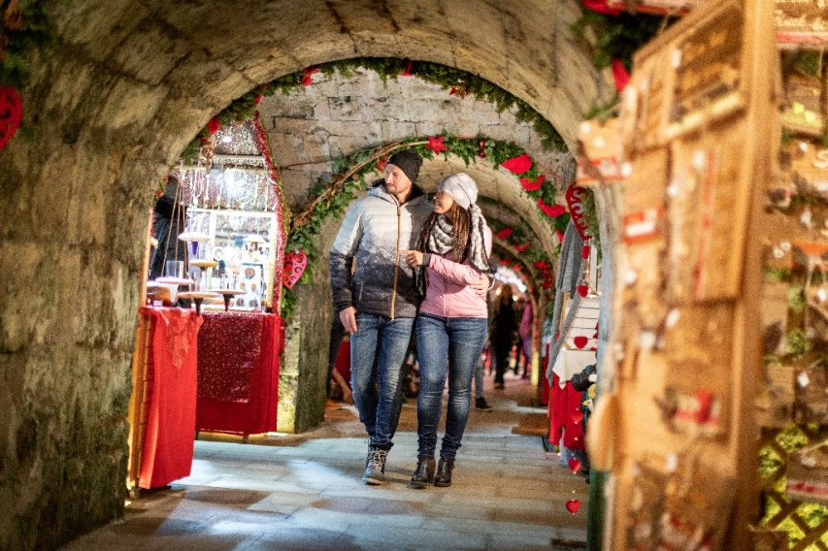

In the courtyards of the fortress, choirs sing Christmas music and carols, which can be listened to while sipping warm winter drinks such as mulled wine and savoring typical Tyrolean dishes. In addition to the market, the fortress offers several places to visit, such as the 60-metre-deep well that drew water directly from the river: the ‘Elisabeth battery’ with its cannons, the ‘Schlossrondell’ with its wooden footbridge, the former state prison inside the Kaiserturm tower with its exhibition ‘Jurisdiction under the Habsburgs’. History buffs can linger at the local history museum with many interesting references to the history of the Tyrol and the exhibition at the artillery workshop ‘Emperor Maximilian and the Kufstein Fortress’.

**Admission to the fortress is free with the KufsteinerlandCard, which every guest receives when checking in to any accommodation in the Kufsteinerland region.**

Also at the Kufstein town park (Stadtpark), the Christmas market is a daily appointment for strolling among the stalls, savoring typical dishes, listening to music and entertaining the children on the merry-go-rounds. The market is very popular with locals, especially families, and is an opportunity for children to discover traditional Christmas delicacies. They toast with typical mulled wine and are enchanted by the Christmas lights and music.

**Market opening in the Stadtpark (town park): 22 November to 22 December; Wednesday to Sunday.**

**Market opening in the fortress: 30 November to 22 December, Saturdays and Sundays.**

[Advent in Kufsteinerland](https://www.kufstein.com/en/culture/advent.html)

***Kufstein is a partner of ‘Advent in Tirol’, the quality label guaranteeing the authenticity of Advent and Christmas atmosphere: the criteria to be met include not only the outward appearance, but also the wide range of offers, such as programs focusing on traditions and customs, the special atmosphere emanating from romantic towns and traditional villages, which know how to make Advent a special experience. The other regions that are part of ‘Advent in Tirol’ are Achensee, Hall in Tirol, Innsbruck, Rattenberg, Seefeld and St. Johann in Tirol.***

[2024 Kufstein Christmas Market | Advent Season | Austrian Tirol](https://www.tyrol.com/things-to-do/events/all-events/e-christmas-market-kufstein)

**CHRISTMAS MUSIC AND CONCERTS**

**The world's largest open-air organ plays on New Year's Eve**

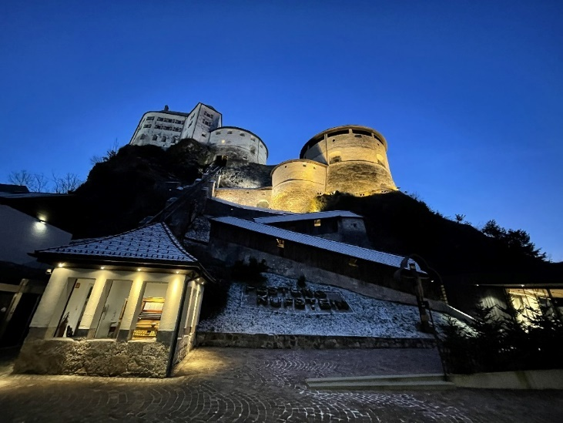

Inside the fortress is the **world's largest open-air organ** (which plays daily at midday, vibrating its 4,948 pipes), every day at noon it plays punctually for about twenty minutes: its music spreads out for kilometers. On New Year's Eve, shortly after midnight, the organ exceptionally plays the **Viennese Waltz**: in the main square of Kufstein, people dance in celebration of the arrival of the New Year the Viennese Waltz, **a tradition in Austria**. This organ, whose official name is ‘Organ of Heroes’, has been part of Unesco's intangible cultural heritage since 2017. It was built in 1931 in memory of the fallen soldiers in the First World War by the master organ builder Oscar Walcker.

**In Erl, a village in Kufsteinerland, the futuristic Festspielhaus theatre hosts top-class concerts during the Christmas season**

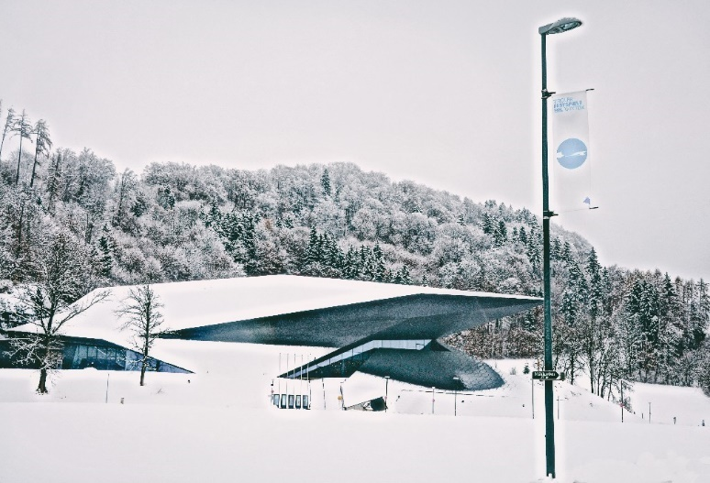

The Festspielhaus theatre in Erl is an architecturally interesting building with futuristic and innovative lines. It is the ideal place to sit and listen to Christmas concert, such as **Bach's Christmas Oratorio** (8 December) and the **traditional New Year's Eve and New Year's concerts**. For those who love classical music, these events are not to be missed: the orchestra is made up of talented musicians, who are able to thrill even the most demanding audiences accustomed to top-class concerts. Amplifying the truly special atmosphere is the location of the theatre, situated in nature, in the middle of pastures, in a municipality of 1500 inhabitants.

[Cultural experience and fun in nature in the Passion Play and festival town of Erl](https://www.kufstein.com/en/tyrol-places/erl.html)

**FESTIVAL OF 1000 LIGHTS**

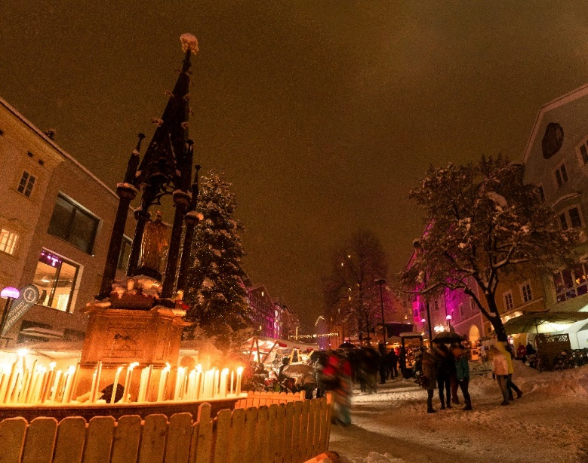

Another magical date: From the 3rd to 5th January, as part of the Christmas festivities, the wonderful **‘Kufstein Festival of 1000 Lights’** takes place. From dusk until 8.30 p.m. the town square and the old town center are lit up with candles, lanterns and torches. It is a swarming of flames, lights, shadows, a scenic play of light and darkness that amazes young and old alike. From windows, in the streets, thousands of lit lanterns sprout up, creating a dreamlike atmosphere. The alleys, which are already fascinating even in sunlight, acquire a fairytale air, the festive atmosphere echoes through the streets and squares. Gastronomic delicacies, musical entertainment and a children's program welcome in the New Year, which started a few days ago.

[1.000 LICHTER](https://www.kufstein.com/en/culture/event-calendar.html#/events/KUF/7f96ac00-6fa8-4a65-a431-28579c5cad5a)

*About Kufsteinerland: Kufsteinerland, with its 8 villages Bad Häring, Ebbs, Erl, Langkampfen, Niederndorf, Niederndorferberg, Schwoich, Thiersee and the town of Kufstein, is home to around 44,000 people and a vibrant business and university centre.*

*It combines creativity and innovation with Tyrolean traditions and international high culture in the Erl Festival Theatre. The mighty fortress overlooking the medieval town of Kufstein, the majestic mountain range of the Kaisergebirge and the gentle alpine pastures on the high plateaus around lake Thiersee and Bad Häring are a characterising backdrop and a place of strength for locals, employees, students and guests alike.*

*In this environment, Kufsteinerland stands for active experiences between working life and everyday life, which can be filled with a unique mixture of tradition and modernity, nature and wellness, culture and sport as well as traditional and international cuisine in the cycle of the seasons. At the same time, Kufsteinerland offers plenty of space for relaxation and tranquillity.*

*Info:* [*www.kufstein.com*](http://www.kufstein.com)*/en*

Press contact:

**Tourism Association Kufsteinerland**

Sabine Rainer-Lanthaler

+43-5372 62207- 22

s.rainer-lanthaler@kufstein.com

presse.kufstein.com

We are happy to provide further information and pictures about Kufsteinerland. You can find printable images and other text material on our website.

https://medienportal-tvb-kufsteiner.px.media/overview